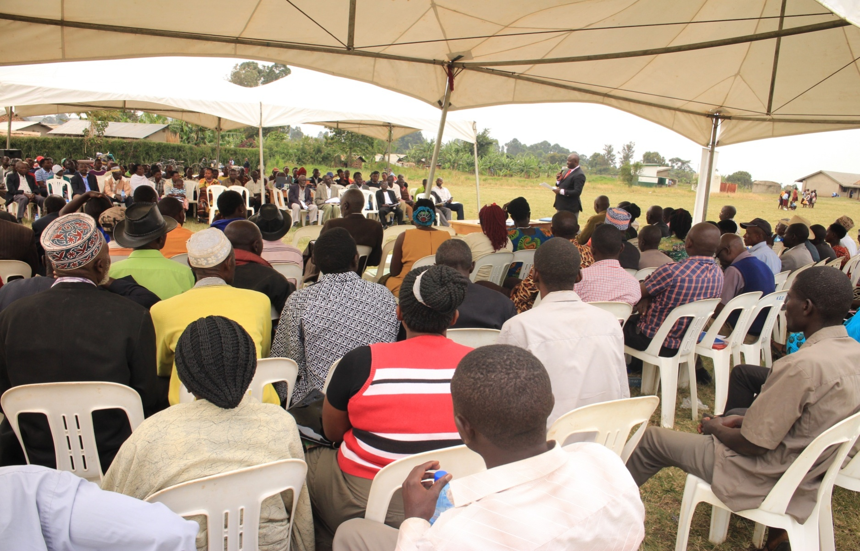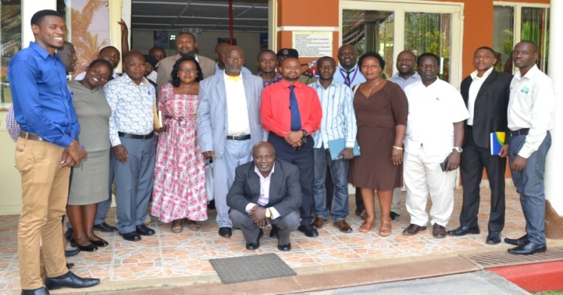

**TORODEV ANNUAL REPORT**

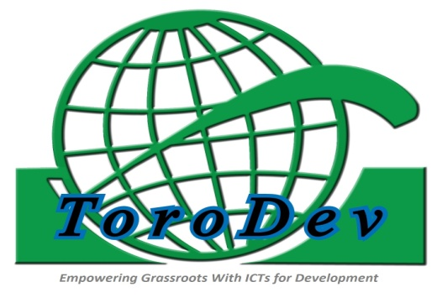

**2018/2019**

Contents

1.0 Introduction 2

**1.1 About ToroDev** 2

**1.2 ToroDev’s Operational Contextual Analysis** 3

2.0 Key Interventions for the period July 2018 – June 2019 4

**2.1 INTERVENTION ONE: Capacity Building of Health Center Management Committee Members in Ntoroko District.** 4

**2.2 INTERVENTION TWO: Accountability Meetings to Improve Essential Service Delivery** 6

**2.3 INTERVENTION THREE: Capacity Building of Rwenzori Journalists’ Forum (RJF) Members** 11

**2.4 INTERVENTION FOUR: Knowledge Sharing Workshop and Coordination meeting of 13 Citizens’ Advocacy Forum Members** 12

**2.5 INTERVENTION FIVE: Orientation training of key District officials on Internet skills and use of the MML eParticipation System platform** 14

**2.6 INTERVENTION SIX: District Local Government-CSOs Forums Meetings** 16

**2.6.1 Ntoroko District Local Government –CSOs Forum Coordination Meeting** 16

**6.4 Kyenjojo District Local Government – CSOs Forum** 18

**2.7 INTERVENTION SEVEN: Rural Radio Debates/Magazine** 19

**2.8 INTERVENTION EIGHT: Radio Debates and Talk shows on Civic Education** 22

**8.1 Held 72 Radio Talk shows on Hits FM, Jubilee Fm and KRC Fm** 22

3.0 ToroDev Regional & International Engagements 24

**3.1 FIFA 2018- Accra, Ghana** 24

**3.2 Africa Tech Forum – Kigali, Rwanda** 24

**3.3 Africa Tech Week – Cape Town, Southern Africa** 25

**3.4 Stockholm Internet Forum – Stockholm, Sweden** 26

**3.5 UPR and FIFA 2019– Addis Ababa, Ethiopia** 27

4.0 Summary of ToroDev’s Key Technical & Funding Partners 28

# 1.0 Introduction

This year annual report gives a detailed account of the organization’s planning and implementation of programs and projects for the period July 2018 – June 2019. It gives highlights of strategic and management intervention milestones and the progress of the projects, the relevance of the project activities within the broad community development programming of ToroDev. Our programming focuses on improved service delivery in key three sectors; Health and Well-being, Education & Skills Development and Economic Sustainability/Development. The report also highlights participatory community development interventions ToroDev was engaged in with in that period of time for sustainable impact as outlined in the Organization’s Strategic Focus/Plan (2016 -2020). The strategic use of ICT4D tools to improve people’s livelihoods by putting emphasis on involving citizens in planning and budgeting process and promoting active public accountability of government agencies remained at the center of ToroDev’s interventions in 2018/2019. During the year, a lot of efforts were also put on converging ICT tools to promote evidence-based advocacy through collection data on status of priority service delivery facilities in western and Northern Uganda. ToroDev strongly believes that the information in this report will be helpful to our beneficiaries, stakeholders and partners.

## **1.1 About ToroDev**

Toro Development Network (ToroDev) is a non-profit organization that engages in community mobilization activities for citizens to freely access equal development opportunities, including gender-sensitive empowerment for maximum resources utilization targeted to more wealth creation. This will eventually lead to poverty eradication in a typical community or society. ToroDev promotes innovation and entrepreneurship skills training and policy research activities to understand the role of both traditional and modern Information & Communication Technologies (ICTs) in accelerating sustainable socio-economic and political development of the poorer and disadvantaged groups of the population. ToroDev’s trainings, research, advocacy for democratic and good governance practices activities are concentrated in the Rwenzori region, western Uganda in the districts of Kabarole, Kyenjojo, Kyegegwa and Ntoroko.

Since its establishment in December 2005 and the subsequent launching of community-led development interventions in early 2006, the founders and management of ToroDev have dedicated themselves to advancing the importance and applicability of ICT skills and services to the rural people. The emphasis is put on how the people in the community can exploit services and opportunities provided by ICT tools and equipment to inform and generate knowledge for demanding accountability from their leaders, create wealth by employable opportunities, small business enterprises (SMEs) start -ups in the agribusiness and other service sectors. ToroDev is governed by a well experienced five members’ Board of Directors with diverse experience in academia, law & human rights, community development, education, health, Research and ICT for Development. The management team is led by the Executive Director and other seven full-time and four part-time staff.

**Vision:**

A society that is empowered with knowledge and leadership skills for positive livelihood

**Mission:**

Promotion of knowledge through appropriate ICT tools for improved service delivery for education health and economic Development

**Goal**:

Empowerment with knowledge and leadership skills

**Core Values (TAPIC):**

1. Team work

2. Accountability

3. Professionalism

4. Integrity

5. Creativity

## **1.2 ToroDev’s Operational Contextual Analysis**

At ToroDev, we understand the potential of access to quality health, education and economic development opportunities have on sustainable human development. A healthy and well educated citizen is more likely to critically question circumstances surrounding him/her and develop approaches to address challenges that such circumstances present at a given period of time. We recognize the revolution of Information and Communication Technology (ICTs) and its potential to address poverty issues among both the urban and rural populations. We understand ICTs in its broadest context – going beyond modern physical computer equipment, software and networks that are often misunderstood to be designed for the elite and urban population, to also traditional and rural techniques of gathering, processing and disseminating information by established rural information systems that use oral sensitization and distribution tools.

Those tools include cinemas, printed posters and other materials, public addresses, community radios and mobile telephony. Therefore, our major activities include; understanding – through research and/or evaluation – the role of ICT in development discourse, provision of equipment and training, setting up networks, platforms that channel evidence data on status of priority public service delivery facilities and bridging the urban – rural digital divide. ToroDev has proved that ICTs possess the potential of easing rural community development research activities - gathering, compiling and processing of data, documenting and disseminating comprehensive and relevant information for activating self-reflection and positive community action.

# 2.0 Key Interventions for the period July 2018 – June 2019

## **2.1 INTERVENTION ONE: Capacity Building of Health Center Management Committee Members in Ntoroko District.**

Prior to the implementation of this activity, a baseline survey was held in April 2017 to know the status-quo of HC IIs, IIIs and IVs in Rwenzori sub region. We engaged with the district health officials, district health executive, chairpersons HUMC and the health centre In-charges who helped in understanding the gaps that exist in the work of health unit management committees especially in planning, monitoring, lobbying & advocacy for improved health care management systems. The field visit team at ToroDev discovered that some members on the committee were serving for the very first time and did not know their roles and responsibilities and also there were changes in policies under the health care sector and as a matter of fact, all of which needed awareness creation through capacity building of stakeholders in this sector.

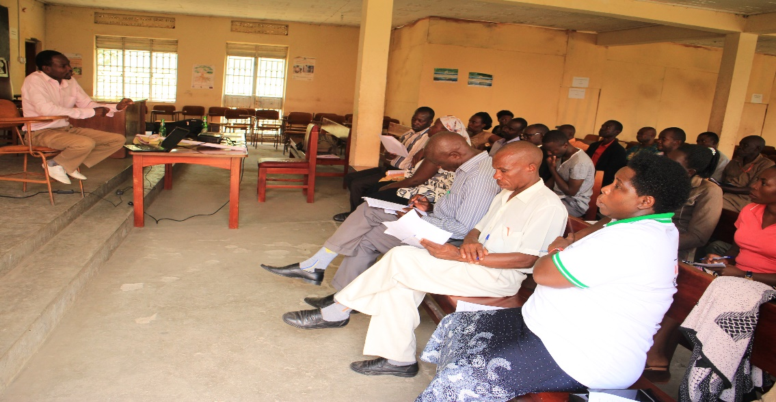

***District Health Officials and Health Management Committee members attending the training***

As ToroDev we aimed at transferring knowledge to HCMC members in matters of health service delivery policies, NMSDS, advocacy using ICT, (online/electronic) drug stock-outs and monitoring effective use of resources at health centers, provide knowledge and competencies on the roles & responsibilities of HCMC explaining the existing policies on Health Care delivery system in the District, Information sharing and advocacy for improved health care system, using modern and traditional tools, etc., but also envisaged to see well streamlined HUMC roles and responsibilities, capacity to conduct meetings for improving performance and health service delivery, among many others.

The capacity building training, a continuation from the previous trainings held in other districts in the previous period was held in partnership with Ntoroko District Local Government with the theme: ‘*Transferring knowledge to Health Unit Management Committees in matters of health service delivery, health policies, advocacy using ICT, drug monitoring and effective use*’.

The training was held on 26th July 2018 at Karugutu town council hall in Ntoroko district. It was facilitated by Dr.Tony Mugisa the deputy DHO Bunyangabu district and Mr. Byaruhanga Patrick the District Health Educator (DHE) Ntoroko district.

The capacity building training targeted all the HUMC members including the In-charges from the 7 government aided health units (HC III’s) in Ntoroko district. A total number of thirty eight (38) participants attended the one day training. Twenty four (24) were males while fourteen (14) were females. Participants were drawn from; Karugutu HC IV, Rwebisengo HC III, Bweramule HC II, Rwangara HC II, Ntoroko HC III, Musandama HC II and Stella Maris all located in Ntoroko district.

The topics covered during the training included but were not limited to; roles & responsibilities of HUMC’s, structure and composition of HUMC, conducting meetings, governance, advocacy using ICT’s, management of medicines and supplies, formation and tenure, budgeting processes, monitoring, etc.

**2.1.1 Key comments**

‘’As a district we have always thanked ToroDev for their good initiatives in our district and now inducting HUMC members on their roles and responsibilities and I believe the gap has been affecting them in their execution of their work. This training is very important for HUMC members as managers of these health facilities and am sure it will equip you with knowledge and skills to effectively implement your roles and responsibilities’’. Said Ms Joan Mughuma, the Deputy Chief Administrative Officer, Ntoroko district during her closing remarks.

‘’I urge HUMC members to cooperate with health unit In-charges such that they can effectively access information which you should share with the community members while playing your role of linking the facility to the community. We know that HUMC members do voluntary work but with the knowledge and skills imparted to you today, Am  hopeful that we are soon witnessing improved health services in the district’’. Said, Dr Tony Mugisa, facilitator during the training.

‘’This training has equipped us with knowledge and skills and we are going to work with the In- charge so that we can equitably be in position to do what we are required to do for improved performance of our health centers”. Said, *Joseph Ndora*, Committee member, Karugutu Health Center IV.

**2.1.2 Action points**

Some action points were developed by participants, they included; conducting regular HUMC meetings, participating in development of health facility work plans, giving accountability quarterly on notice boards and radios, fencing the facility for the security of people and property, holding bi-annual community dialogue meetings, witnessing delivery of drugs and general monitoring of the health facility, *re-structuring Health Center Management Committees so that they can come out with potential members who can work better for improvement of health services in their communities*. They also suggested to link up with the In-Charges to know the planned targets of each health center in order to help them monitor effectively and also forming a WhatsApp group page to improve their communication levels, all aimed at improving health services in the district.

## **2.2 INTERVENTION TWO: Accountability Meetings to Improve Essential Service Delivery**

With continued support from SIDA, ToroDev under a project titled; *“ICT for Enabled Citizens’ Participation, Public Accountability & Democratic Engagement in the Rwenzori sub-region, Western Uganda*” has further held public accountability meetings at sub county lower local level governments. Accountability meetings fall under the project objective of growing the capacity (access, skills and knowledge) of civic groups, human rights defenders (HRDs) and media to use ICT effectively for accessing and sharing information, advocating and raising awareness on service delivery, equality, the right to information and free speech.

The meetings were organized in partnership with Citizen’s Advocacy Forums to discuss specific health, education and economic development sustainability sectors as reported by citizens through the on-line platform MML e-participation system.

Two (2) meetings were held; One (1) in Harugongo Sub County, Kabarole District and the other from Kigambo Sub County in Kyegegwa district.

**2.2.1 Meeting held in Harugongo Sub County, Kabarole district**

Accountability meetings are organized for citizens to have an engagement with their duty bearers. During these meetings, accountability is given and achievements and challenges shared such that citizens can be in the know of what is happening in their communities as they take part in the governance processes of their district all aimed at improving service delivery. Issues raised by citizens through MML e-participation system were also shared for duty bearers to pay attention and provide solutions.

The public accountability meeting was held at Harugongo trading center in Harugongo sub county, Kabarole district on 19th July, 2018 with a goal of presenting issues generated through an online platform- MML e-participation system from citizens in the Rwenzori region and specifically issues raised by citizens from Harugongo Sub County.

District and Sub County duty bearers were invited to respond to service delivery issues raised by citizens through MML system as a way to jointly look for solutions on the prevailing gaps as far as improved services in communities is concerned. Key service delivery sectors of Health, Education, and Economic development were focused on for Harugongo meeting.

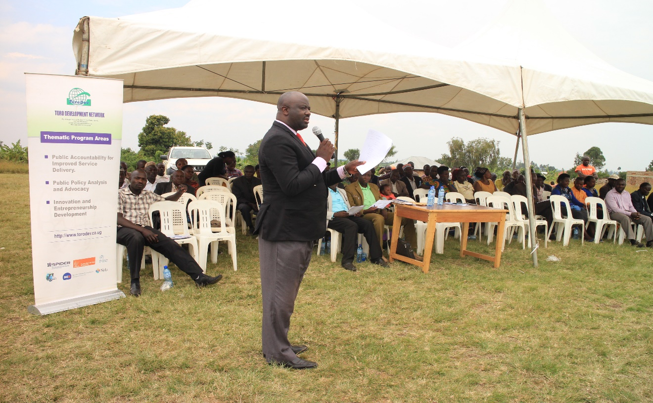

***The District Chairperson – Kabarole, giving accountability during one of the meetings***

One hundred ninety five (195) people attended the meeting and these included; the district chairperson Kabarole, Harugongo Sub county chairperson, Harugongo Sub county district councilor, Sub county chief, head teachers, schools and Health Management Committees members, Sub county, Parish and village councilors, Security officials, parish and village local council chairpersons, Advocacy forum members, CSO’s, Elders, Religious leaders, Media and local citizens from Harugongo Sub county.

Particular issues generated through MML e-participation system from Harugongo Sub County for the month of June 2018 were shared. While sharing the report, the M& E officer ToroDev said, as an organization we promote the use of ICT’s in the Rwenzori sub region through the use and promotion of different ICT tools like radios, phones and now with the online MML e-participation system called ‘Me and My Leader’ (MML) where citizens can send a prepaid Sms to 6115 commenting on issues of service delivery from their respective communities.

**2.2.2 Key issues from citizens**

Citizens from Harugongo Sub County were complaining of “*congestion at Nyantabooma maternity ward (Nyantabooma HC 11), insufficient drugs at the facility, absenteeism of health workers, limited access to safe and clean water, lack of a fence at Harugongo Primary School which put pupils at risk due to community members trespassing around it, need for construction of Wamikira bridge that connects Busoro to Harugongo Sub Counties, etc”.*

**2.2.3 Key Comments from duty bearers**

*‘’We have earmarked one hundred eighty million shillings (180m) for the construction of a maternity ward at Nyantabooma HC II which has been elevated to a HCIII status. Its elevation will increase drug supplies, increase staffing level which will automatically improve services and as a district we are committed to construct the maternity ward to improve the conditions of our mothers whenever they come for delivery at this facility*”. Said Hon Richard Rwabuhinga, district Chairperson, Kabarole.

*‘’We have already talked to National Water and Sewarage Cooperation an organization responsible for supply of safe and clean water in the country to extend water services to Harugongo Sub county and we expect by end of 2019 people of Harugongo will be accessing safe and clean water.’’* Said Hon Richard Rwabuhinga, district chairperson.

*‘’As a district, we are going to construct Wamikira bridge at a cost of fifty million shillings (50m) and have also secured twenty million shillings (20m) for upgrading of Nyabukara-Harugongo-Geme road to ease transportation of people and goods to markets.’’* Said the district chairperson.

**2.2.4 Outputs**

* One hundred ninety five (195) people attended the meeting including the district chairperson and department heads, sub county duty bearers, head teachers, management committees, parents, media,etc
* Key challenges affecting health, education, water, roads in Harugongo Sub County identified and presented to duty bearers and technocrats to provide solutions
* Parents mobilized to support their children in schools by providing scholastic materials and lunch in order to keep them in school and complete their studies
* **Sub County leaders pledged to mobilize the youth** to benefit from government programs like Youth Livelihood Program (YLP) to reduce unemployment and increase income at house hold level.
* Acton plan developed.

**2.2.5 Immediate Outcomes**

**Maternity ward construction:  A maternity ward at Nyantabooma HCIII to be constructed at a cost of one hundred eighty million (180m) shillings.** Sub county duty bearers, HUMC members, health In- charge, advocacy forum members and ToroDev pledged to follow up the construction that will commence in the 2018/2019 financial year. Construction work started and it is expected that by end of 2020 the maternity ward will be complete.

**Road construction:** Construction work for Nyabukara-Harugongo-Geme road at a cost of fifty million (50m) shillings to commence immediately under the supervision of Advocacy forum members and Sub county leaders.

**Bridge construction:**  Construction of Wamikira bridge connecting Busoro and Harugongo Sub counties to be done effective August 2018.

**Safe and clean water**: Extension of water by National Water and Sewarage Cooperation to citizens of Harugongo Sub County to be done and will be followed by district, Sub county leaders, CSO’s and forum leaders

**Sub County headquarters construction**: The district has secured fifty four million (54m) shillings for the completion of Harugongo sub county headquarters. The Sub county leaders need to follow this as an immediate action.

**2.3 Held a Public Accountability Meeting at Kigambo Sub County, Kyegegwa District**

The meeting was organized in partnership with ‘Aturanagyayo’, a community advocacy group based in Kakabara Sub County in Kyegegwa district. It was organized to give a platform to electorates/citizens to engage with their elected leaders and also receive accountability of what has been done by their leaders as a way of participating in the governance processes of their district. Such an engagement is the only way citizens can get clear accountability of what their leaders have done, what they have failed to do and why but also getting to understand what is planned for them. The meeting was also an avenue for ToroDev to present issues generated through MML e-participation platform focusing on key service delivery sectors of health, education and economic development. The e-participation system/platform, ‘Me and My Leader’ (MML) where citizens send a pre-paid Sms to **6115** to engage duty bearers on service delivery issues aimed at reducing the information gap that exists between citizens and duty bearers but also getting evidence based data to engage leaders in development programs was promoted.

The public accountability meeting was held on August 2nd, 2018 at Kyanyambali primary school in Kyegegwa district. It was attended by over three hundred (300) people who included; *the district chairperson Kyegegwa, operation wealth creation district coordinator, district agriculture officer, area councilors including the district councilor, head teachers, political and technical officers at Sub county level, local council I chairpersons, health unit management and school management committees, elders, religious leaders, media and local citizens.*

**2.3.1 Key comments/issues from citizens**

Citizens from Kigambo Sub County, Kyegegwa district said *they did not understand the operations of Operation Wealth Creation (OWC) program. They complained of receiving limited seeds/seedlings & breeds and receiving them late at the end of planting season, health workers from different health facilities report to work late, limited drugs in health facilities, lack of safe and clean water especially people from Kitalesa village Kigambo Sub County in Kyegegwa district, lack of a secondary school in Kigambo Sub county, absenteeism of teachers and learners, under staffing in schools and health facilities, limited infrastructure in schools like desks*, etc. the issues were presented as generated through the system/platform before duty bearers such that a lasting solution to improve services in communities can be sought.

**2.3.2 Key responses from duty bearers**

**Elevation of Kigambo HC II to HC III**- The district chairperson said they submitted 3 names of health centers to be upgraded including Kigambo HCII, Karwenyi HCII and Bigogo HCII. This financial year government has elevated Karwenyi and promised people that next financial year Kigambo will be elevated to a HC III status so that the facility can provide better health services to the populace.

**Destruction of wetlands**- ‘*’All wetlands belong to government, we have started destroying trees and other things that are not friendly to the environment especially those in wetlands but also as a district we have passed a budget to move around the district sensitizing citizens to stop farming in wetlands. Let the issue of protecting wetlands be a responsibility of everyone’’*, Said Hon Kisoke John, the district chairperson.

**Understaffing in Schools and Health facilities**- We are going to recruit more teachers and post them in schools with staffing gaps to reduce teacher: pupil ratio next financial year and also use the merger resources to improve on the infrastructure beginning with schools that are really doing badly. Also we are going to sit with the DHO to plan on how we can recruit more health workers and post them to health facilities with staffing gaps to improve health services in the district.

**Lack of a secondary school**- The district chairperson requested the sub county leadership to immediately begin mobilizing citizens to start a community secondary school and there after his office will request government to support them much as it is a government policy to have a government aided secondary school in every sub county in the sub county country.

**Absenteeism of health workers**- The district chairperson pledged to meet all health workers together with the district health officer (DHO) the following week to sensitize them on their roles and responsibilities while serving community members. He promised to intensify monitoring together with sub county leaders to tackle absenteeism of health workers and teachers in schools.

**Operation Wealth Creation program**- It is very true there are still gaps in the operations of this program. What they are giving is not leading us out of poverty. For example they gave the district 16 heifers last financial year, what can it do to the population of Kyegegwa as a district? ‘*’We are going to seriously talk to the managers of the program if they cannot increase their supplies at least they give us money we buy fuel and construct roads for the people to transport their goods and easy access to markets’’*, Said John Kisoke, district chairperson while responding to issues from citizens.

**Access to safe and clean water**- *‘’People of Kamuganyi, Kyanyambali and other areas please we urge you to be patient for we are aware of the issue of water and how it is affecting you in your communities. As a district together with my councilors we are working tirelessly to see that you access safe and clean water before the end of this financial year 2018/2019. We promise to work on the issue of water as soon as* *possible the way we have worked on Nyakagongo, Kihorongwa, Kinyambale B cell shallow wells’’*, Said John Kisoke, the district chairperson.

An action plan was made on how to follow the pledges, monitoring service delivery and advocating for issues that need further engagements.

## **2.3 INTERVENTION THREE: Capacity Building of Rwenzori Journalists’ Forum (RJF) Members**

The One day capacity building training was held on 21st, March 2019 at St Joseph Inn Virika, Fort Portal Kabarole District. Twenty five (25) journalists that were sampled from eleven (11) local Fm radio stations located in the 5 districts of Rwenzori Sub Region including those from print and electronic media that included; New Vision, Daily Monitor, Orumuli, etc participated. Ninety percent (90%) of participants were from radio stations and 10 % from print and electronic media institutions.  The selection of participants was 50% female and 50% male. Participants were drawn from Kabarole, Kyenjojo, Kyegegwa, Ntoroko, Bundibugyo, Kamwenge and Kasese districts. The training was facilitated by Madam Enid Ninsiima from Daily monitor Kasese bureau and Madam Josephine Kasande of Rwenzori Women’s Network, a local NGO in Kabarole District.

The training aimed at building the capacity of reporters and other journalists in enabling them acquire knowledge and skills in Gender-Sensitive Reporting on Improved Public Service Delivery in Health, Education, Economic Development & Investigative Journalism in the Rwenzori Region.

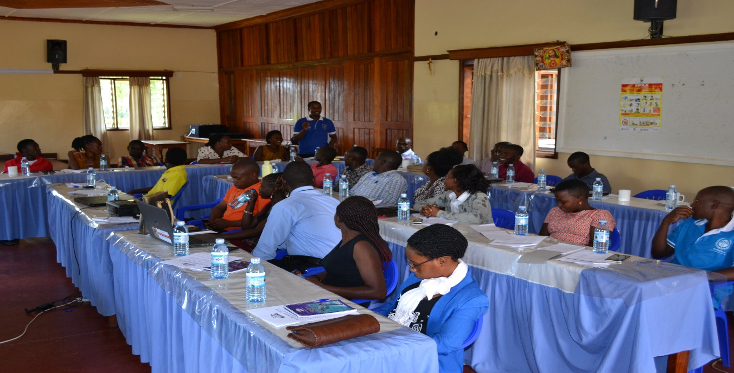

**Members of the Rwenzori Journalists’ Forum participating in the Capacity Building Session facilitated by ToroDev**

**2.3.1 Key quotes from participants**

‘’Investigative journalism has declined in the Rwenzori Region, so this training will orient and awaken us to deeply investigate a single topic focusing on health, education, youth livelihood program and others. From this training I have also learnt that one of the most important skills of a good reporter is the ability to simply, convincingly, and clearly explain what he/she wants to say. A good way to do so is by comparing with generally known information or everyday situations”. Said Kirungi Patra News editor, KRC FM.

“I thank ToroDev for organizing this training, it’s good that I have got knowledge regarding Investigative and Gender-sensitive reporting which will help me determine what has happened according to the existing evidence and very often predict what is going to happen. This training will help us deeply investigate key priority service delivery sectors’’. Said Gerevazio Ngabirano, Voice of Kamwenge.

**2.3.2 Action point**

Participants agreed that there is need for continued sensitization and training of journalists in government policies, local government Act, the constitution, etc. There is also need to keep journalists highly engaged and active through supporting their quarterly knowledge sharing workshops under RJF and the need for continued sensitization of journalists on ethics and standards as key principles in journalism. There was sharing of MML e-participation system especially the e-participation module and e-decision making during the training workshop. Journalists acquired knowledge and skills on how to use MML e-partcipation system to share their service delivery issues as well as receiving feedback from their duty bearers all aimed at sharing information and advocating for improved service delivery.

**2.3.3 Outputs**

* Knowledge and skills acquired by twenty five (25) journalists in Gender-Sensitive Reporting on Improved Public Service Delivery in Health, Education and Economic Development and Investigative Journalism in the Rwenzori Region
* Twenty five (25) journalists acquired knowledge and skills on the use of MML e-participation system
* MML e-participation system promoted
* Action points for follow up set

## **2.4 INTERVENTION FOUR: Knowledge Sharing Workshop and Coordination meeting of 13 Citizens’ Advocacy Forum Members**

ToroDev for the last 8 years has initiated a total number of Twenty One (21) advocacy forums distributed in 4 districts of the Rwenzori Sub-Region.  The Twenty one advocacy forums were formed by 120 rural monitors who were trained by ToroDev in online advocacy, monitoring service delivery using online social media/ICT tools like Ushahidi platform for online documentation, visualization and mapping.  Each forum has a maximum number of 50 members where 40% are women and 60% youths. They have played different roles including monitoring  of public services, lobbying and advocating for improved service delivery, demanding accountability from duty bearers using both traditional and modern platforms, defending people’ rights, etc

The knowledge sharing workshop and coordination meeting was held on 19th/ March / 2019 at ToroDev offices in Fort Portal, Kabarole district. A total number of Twenty Six (26) members’ from 13 advocacy forums attended. The workshop/meeting aimed at planning, sharing challenges encountered in the previous period, harmonizing on how best to address the challenges, sharing work plans for 2019, etc among forum members.

There was also team planning among advocacy forum members on how MML e-participation system can be promoted. While sharing with forum members, Shiela (ToroDev’s M&E officer) said ToroDev developed an online platform called, “Me and My Leader” (MML) where citizens use radio, internet, and Sms to participate in the discussions. The purpose of the system is to facilitate an open discussion between duty bearers and citizens to be more involved in government decision making, ongoing government initiatives in communities and citizens to engage duty bearers and express their concerns on the state of service delivery in lower level communities.

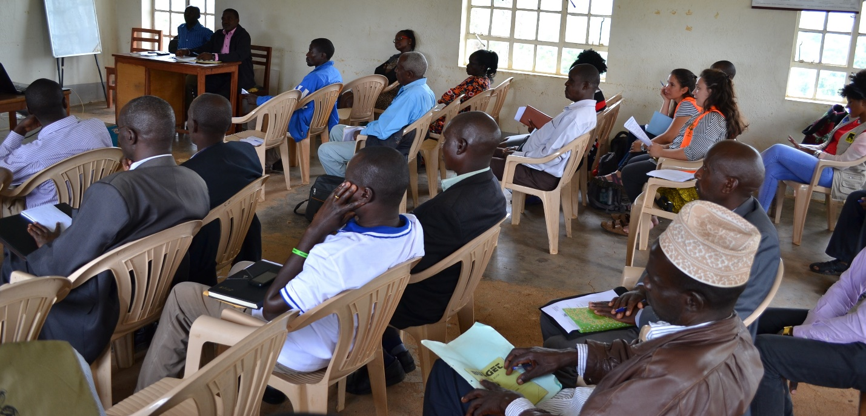

**2.4.1 Key comments from participants**

“MML e-participation system is a good initiative, as Katebwa Forum we plan to move in villages sharing information about MML e-participation system and also share posters as a way of popularizing and promoting the system”. Said Ezra Muhindo, Leader of Katebwa forum

‘’MML e-participation system will make our work easy, We have been oriented let us go back and teach others about this system, we need to share issues and encourage our own members to use it”. Said Muntu Willy from Ntoroko

“*We have faced challenges of denial by responsible officials to give us information at sub county and district levels even after going through the right channels. We request ToroDev to support us in accessing information because it is a bench mark for our advocacy work”.* Said Ssenyonjo Mukwano from Mugusu Peoples Rights and Development forum.

**Action:** Participants requested ToroDev to come up with an umbrella organization that can bring all the forums together and to support this initiative for sustainability and resource mobilization. ToroDev believes members of advocacy forums can be ambassadors in their respective districts in advocating for improved service delivery and promoting MML e-participation system.

**2.4.2 Outputs**

* Action points on sustaining the groups reached
* Proper channels to access information from government suggested
* Work plans and solutions to challenges encountered by forum members discussed
* Twenty six (26) forum members equipped with knowledge and skills on MML e-participation system
* MML e-participation system promoted and ways to promote it further suggested
* Plans and key guidelines in organizing accountability meetings agreed on

**2.4.3 Outcomes**

* Increased number of people using MML e-participation system
* Channels to promote the system suggested

## **2.5 INTERVENTION FIVE: Orientation training of key District officials on Internet skills and use of the MML eParticipation System platform**

ToroDev developed an online platform called MML ‘Me and My Leader’ e-participation system to increase participation of grass root citizens and collect evidence-based data to support offline engagements with leaders on priority service delivery needs and responses on the status of service delivery for democratic engagement processes in their respective communities.

The need to share experience with key service delivery sector heads of departments at district level on public policy framework, advocacy & engagement, internet use and use of MML e-participation system findings in discussions and receiving citizens’ concerns as well as giving feedback under e-decision making module was identified. ToroDev went ahead to mobilize and share with the said officials on how they can respond to issues raised by citizens through the platform.

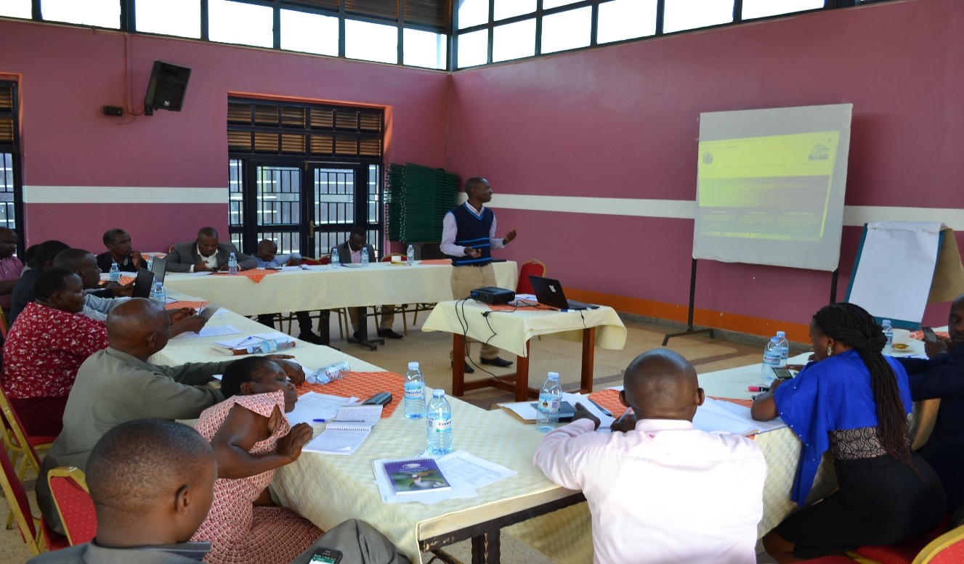

***Participants (District officials) attending the training in Kyenjojo District facilitated by ToroDev staff***

The training targeted fifty two (52) district officials especially heads of departments from the 4 districts of Kabarole, Ntoroko, Kyenjojo and Kyegegwa. Of the fifty two (52) participants, eight (14) were females and thirty five (38) were males. The four districts were zoned into two locations; Kabarole and Ntoroko were oriented at Ataco Country Resort in Fort Portal on 12th March 2019 while Kyenjojo and Kyegegwa were oriented on 14th March 2019 at Tooro Royal cottages in Kyenjojo district.

The orientation training was attended by key heads of departments like production, planning unit, community based services, health, education, Biostasticians but also included RDC’s, district speakers, DISO’s, DPC’s, police and media among others.

During the training, participants were given knowledge and skills on using the system, the system has 3 key modules; e-Information, e-Discussion and e-Decision making where duty bearers can log in and respond to issues raised by citizens from communities. The system collects evidence based data which is gathered and reports for respective districts generated and shared by ToroDev with district officials for action, those that need urgent attention are always forwarded to responsible duty bearers without necessarily waiting for the end of month. Said David Kugonza, Strategic Partnerships and Communications Officer at ToroDev during the orientation training.

**2.5.1 Key comments from the training**

‘*’ICT has a very big role in the development of a country, the e-participation system we are promoting collects evidence based data from communities and when we talk of e-participation we basically mean citizens participating and also proposing how things should be done. As a country we need to reach the Uganda Vision 2040 when every citizen can contribute /participate, make interactions and engagements where we have alternative choices. We need to develop the spirit of ownership on programs and projects within our communities’’*. Said Johnstone K Baguma, Executive director Toro Development Network (ToroDev).

“We need to join efforts to address Poverty and engage people to do development activities to create avenues where Sustainable Development Goals (SDGs) can be popularized on such ToroDev initiatives. If we use the platform for the intended purpose as oriented, issues of service delivery from our communities will be addressed’’. Said Daniel Musinguzi, District Planner Kabarole.

‘*’The role of ICT is to facilitate free access to information and communication channels to improve service delivery as this platform. Am sure if we used this platform, citizen interaction to improve public services, reduction and misappropriation will be dealt with and we shall have improved trust and citizen motivation to contribute to revenue/taxation and other government development initiatives. Such a platform saves time by going on ground to look for the same information and reduces the cost because information finds one in his/her office and what is expected of us is having an answer to the issues and giving feedback to the sender using multiple information dissemination channels’’*. Said Twooli Yafesi, District Community Development Officer (DCDO), Kyenjojo district.

**2.5.2 Outputs**

* MML e-participation platform/system promoted to 52 key district officials
* 52 key District officials empowered with Knowledge and skills on the use of e- decision module on MML platform.
* Fifty two (52) district officials received Knowledge/ information and skills on the role of ICT in improving service delivery
* Five (5) action Plans Set including; Inviting key duty bearers for radio discussions to respond to issues raised by citizens through the system, notifying duty bearers on urgent issues raised through the system weekly, linking the MML system to all district local government websites for easy information access and dissemination, etc.

## **2.6 INTERVENTION SIX: District Local Government-CSOs Forums Meetings**

### **2.6.1 Ntoroko District Local Government –CSOs Forum Coordination Meeting**

District local government (DLG) – Civil Society Organizations (CSOs) coordination meetings were held under the theme; ‘***Planning Together, Accounting together’***. The initiative to have CSOs-district local governments aimed at increasing coordination and strengthening collaboration among CSOs and district local governments in the region.

The Ntoroko district coordination meeting was held on 26th March, 2019 at Karugutu Town Council hall in partnership with Ntoroko NGOs/CBOs forum. It aimed at ensuring adequate collaboration and coordination between NGO’s/CBO’sandthe district, bridging the gap between the inter NGOs coordination and towards the district line departments in terms of sharing plans and budgets with the purpose of improving service delivery and avoiding duplication of services among NGO’s. The meeting further focused on sharing achievements of the district for the financial year 2017-2018, understanding the roles of the district NGO committee, their operations, sharing highlights of the current NGO Act and challenges affecting CSOs in Ntoroko district. It was attended by 46 participants, eighteen (18) women and twenty eight (28) males that included; the district chairperson, the deputy Chief Administrative Officer, RDC, heads of departments, district planner community development officers, CSO’s representatives and the media.

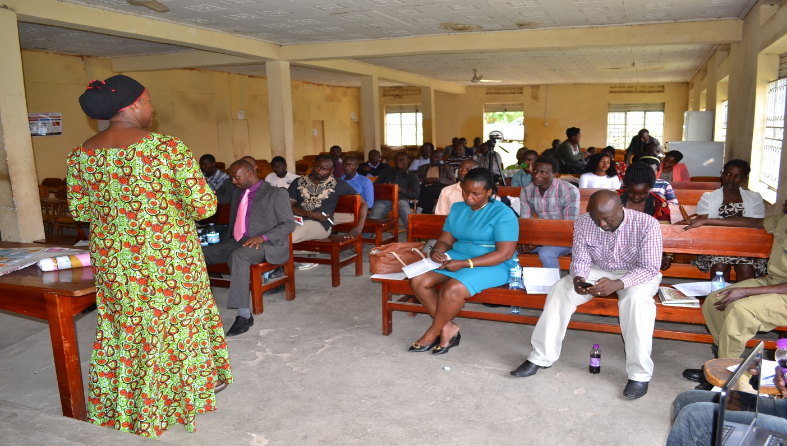

Information on ToroDev’s initiated online platform MML ‘Me and My Leader’ e-participation system where citizens can send Sms to 6115 on issues affecting them within their communities was shared during the meeting. Citizens use internet, radio and Sms. The platform facilitates *an open conversation between citizens from hard to reach communities and duty bearers and make citizens more involved in the government decision making processes and help them follow government implemented projects in the Country. The platform can be reached* via [*http://mmlonline.org*](http://mmlonline.org)

**2.6.2 Key Comments from Participants**

“I thank ToroDev for coordinating us to plan together, as Ntoroko our CSOs are really not coordinated and this is the time to team up and work for our district. We shall strengthen our coordination and monitoring as we plan and work together with CSOs which is key in improving services in all sectors of development’’. Said Hon. Kyamanywa Timothy district chairperson, Ntoroko.

“I request all CSOs operating in the district to register with us, this will make coordination and monitoring effective and also help in avoiding duplication of activities. We need to plan and work together if we are to improve services in all development sectors”. *Said Mughuma Joan Deputy Chief Administrative Officer, Ntoroko district.*

“Our mandate is to advise and provide adequate data and information to fulfill the requirements of local governments and our development partners. Therefore, CSOs need to submit their work plans and budgets to the planning unit and there after their work plans will be incorporated in the district main work plan to ease coordination”.  Said Kanimi Kaganda District Planner, Ntoroko.

**2. 6.3 Output**

* Forty six (46) people participated in planning for their district
* MML e-participation system promoted and knowledge and skills on system use acquired by participants
* Plans on how to address key issues raised through the system reached between district local government officials and CSOs representatives.
* Key service delivery issues in the district discussed among district officials and development partners
* Action plans including how best to improve the coordination of CSOs within the district suggested

## **6.4 Kyenjojo District Local Government – CSOs Forum**

The one day coordination meeting was held with the main purpose of following up action points from the previous meeting and sharing experience and challenges as CSOs working in the district. It was also a platform to present the monthly MML reports generated through ToroDev’s initiated online platform called ‘Me and My Leader’ (MML) e-participation system specifically focusing on the 3 main service delivery sectors of health, education and economic development. More discussions focused on achievements of the district for 2018, understanding the roles of the district NGO committee, their operations, highlights of the current NGO Act and challenges affecting CSOs in Kyenjojo district etc.

The meeting was held on 28th March, 2019 and was attended by sixty eight (68) participants (Twenty seven (27) females and fifty one (51) males who included; Deputy Chief Administrative Officer, Deputy District chairperson, Heads of departments, district speaker, district planner, 12 community development officers, 15  CSO’s representatives and the media.

**6.4.1 Key Comments from Participants**

“This is a good opportunity to plan, coordinate and partner together as Local government and CSOs to jointly address challenges identified in the education, health and economic development sectors. In our previous engagement, we agreed to jointly monitor schools with an intention of fighting high school dropout in UPE schools. We did so and already some sub counties in the district have set tough bi-laws to arrest parents who do not send their children to school”. Said Madam Tibakanya Gertrude, the District Education Officer (DEO), Kyenjojo.

“I remember in the previous engagement, we agreed to lobby the Sub county council of Bugaki to set up Bi-Law to arrest children who were not attending school but loitering in Markets during school days. The sub county council agreed to our request and as we talk the Bi- Law is being implemented and enforced. We have arrested a number of them and schools are now registering a good number in attendance”. Said Hon Businge Joseph Sub county chairperson, Bugaki, Kyenjojo District during a plenary.

“There is improved information flow between the government officials and NGOs; this has improved because of planning & budgeting together and improved coordination. Let us keep sharing our work plans and budgets and in that way we shall be able to know and understand better which CSO is doing what and where something that will curb duplication of work in our operation areas’’. Said Richard Businge district planner, Kyenjojo.

**6.4.2 Outputs**

* Sixty eight (68  ) participants attended the one day coordination meeting
* MML e-participation system promoted and knowledge and skills on how to use it imparted to 68 participants
* Joint planning on how to address issues including those generated through MML system reached
* Six (6) key service delivery issues discussed in previous meetings followed to ascertain how far the citizen concerns have been addressed.
* A CSOs position paper to be shared during the district budget conference in December discussed and a steering committee elected to develop it
* Local government and CSOs to continue doing joint monitoring of schools and health facilities. The district Health & Education department, CSOs & ToroDev will take lead beginning March 2019.
* Joint efforts to sensitize  parents to keep their children especially girls in schools emphasized, NGO forum and God’ care Ministries a local NGO in Kyenjojo district to take lead by  March 2019

## **2.7 INTERVENTION SEVEN: Rural Radio Debates/Magazine**

Rural Radio Magazines/Debates is a concept that was initiated after realizing very few women were participating in our live service delivery advocacy radio talk shows in the Rwenzori sub-region, western Uganda. Women’s’ participation in the mainstream radio and open public accountability advocacy and engagement, planning and budgeting processes is marginal.

Limited participation of women is attributed to poverty, ignorance, intimidation cultural beliefs and practices which limit women in decision making processes. Interestingly, women are the most affected by poor government policies and poor service delivery because they take the biggest responsibility in feeding the family, educating the children and taking care of the family medical needs. ToroDev after realizing this gap initiated the rural radio debates where women and youths are the main target. Rural radio/magazine focuses on capturing especially women’s voices on governance and service delivery issues affecting them in their communities and thereafter amplified on Jubilee radio on ToroDev supported program that is aired every Sunday 8:00-10:00pm for duty bearers to pay attention and find solutions to the issues raised. Participants’ selection criteria is 80% rural women and 20% youth and other stakeholders like technical leaders.

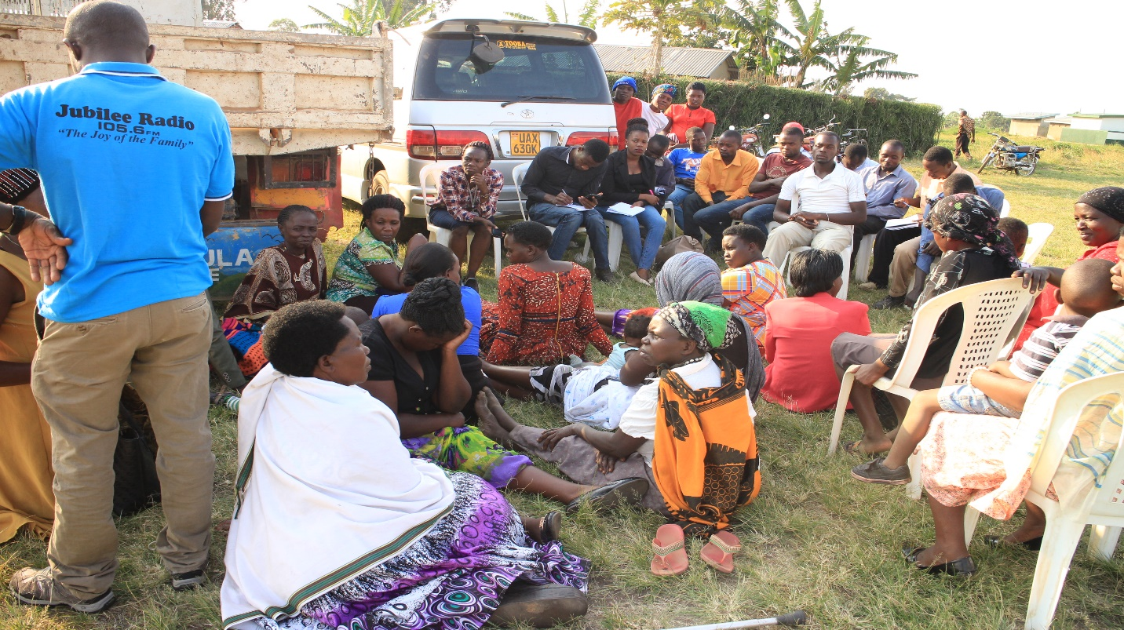

In the entire reporting period, seven (7) rural debates/magazines were conducted between 23/7/2018 and 19/12/2019 from the sub counties of; Kakabara, Bugaki, Hakibaale, Harugongo, Karugutu Town Council, Karago Town Council and Kyenjojo Town Council. Each debate was attended by between 45-65 people, 80% being women. Issues of governance, dialogues on democracy and social accountability focusing on health, education, economic development, road sectors were given attention in 2018/2019. Articles were posted on ToroDev blogs and other social media platforms like face book. ToroDev facilitated journalists to go and record the voices and the issues discussed were recorded and broadcasted live on Jubilee radio during the ‘Listener’s forum’ program that is broadcasted every Sunday 8:00-10:00pm for the duty bearer’s intervention.

**7.1 Key issues/comments from rural debates/magazines**

*“We are dying of typhoid as a result of drinking dirty water, we have no boreholes and shallow wells and can hardly access safe and clean water. We request the sub county water board and the district water department to work together and improve the problem of safe and clean water challenges in our communities”.* Said Racheal Ngonzi from Igunda village, Kakabara Sub county in Kyegegwa district.

“*There are no drugs at the health facility whenever we visit there. There are few health workers especially nurses who sometimes fail to manage the big numbers of patients who visit the health facility. Our children work long distances to access school yet every parish is supposed to have a primary school according to government policy. This has increased dropouts especially for the girl child. We request concerned authorities at all levels to intervene and solve the health and education challenges affecting us*”. Said Gorreti Tumuhairwe a resident from Mukabwera village, Kakabara sub county Kyegegwa district,during the rural debate.

*“During campaign period political aspirants especially members of parliament pledge a lot of things to be done in our communities like water, roads, markets, improving education standards, etc after being elected they disappear and come back when seeking for re-election. We need them to update us on what they have been doing for us, to share their plans on what they intend to do for us. We request our leaders to come back on ground and hear our issues/views instead of guessing them”.* Said Mary Kaija a resident of Karugutu south in Karugutu town council, Ntoroko district.

*“Our greatest problem is lack of clean and safe water and it has been a challenge for 4 years now, duty bearers have not paid much attention to solve the problem. There is 1 borehole serving over 15 villages and this has forced us to get water from swamps which is a health risk to us. We call upon leaders to look into the issue and solve the water problems in our communities*”. Said Annet Kabacwamba a resident of Rwabaganda village Bugaki sub county Kyenjojo district.

*“Our roads are impassable during rainy season. This has negatively affected farming and transportation of goods and people. We request duty bearers to improve the road network especially Rwabaganda-Muchwamba road and also work on Muchwamba bridge”.* Said Jane Topista a resident of Rwabaganda, Kyenjojo district.

*“Operation wealth creation program has not yet benefited us as women, they bring seeds/seedlings without informing us and many times they bring them late after planting season and this has affected us as farmers in terms of planning. We request the program coordinators to involve the beneficiaries in all stages such that we can decide on what to plant and when other than forcing items on us which end up sometimes drying up and failing to yield positive impact*”. Said Stella Kabayagaa resident of Busaiga parish Harugongo Sub County in Kabarole district.

The issue of harassment and mistreatment of patients at Nyantabooma health center was reported in the previous rural debates. We are happy to report that this time health workers no longer mistreat /abuse us, they are cooperative and they serve us based on our needs and so fast. This issue was confirmed by a team of civic group members from Harugongo community development forum when they carried out a field exercise in August 2018. ‘We interacted with over 10 patients the whole number confirmed that health workers attitude has changed, they no longer mistreat patients, they are now friendly because women complained during the rural debate and this has increased the number of patients accessing the facility to get health services’ Said Mutegeki Robert member of Harugongo Community Development Forum during the rural debate.

**7.2 Outputs**

* Issues of governance and service delivery presented before duty bearers
* Over 10 issues as raised by citizens responded to by duty bearers
* Issues from hard to reachareas/communities with poor essential service delivery and those that needed urgent attention presented before duty bearers for solutions
* Seven (7) rural radio debates/magazines successfully held
* Thirty five (35) political and Technical leaders including; district chairpersons, heads of departments, councilors, management committees, security agencies, etc participated in the 7 rural radio debates/magazines.
* About three hundred fifty (350) people, 220 women and 130 youth and males attended the 7 rural debates/magazines from the 4 districts of Kabarole, Kyenjojo, Kyegegwa and Ntoroko

**7.3 Outcome of Rural Radio Debates/Magazines**

* Gap between citizens and their leaders both political and technical (Duty bearers) bridged
* Improved service delivery especially in health and education sectors as witnessed by testimonies from citizens and commitments from leaders
* Increased participation of women and youth in governance issues of their districts/communities
* Improved accountability from leaders on how public funds have been spent
* Improved awareness of local citizens on governance issues and confidence in demanding accountability from their leaders

## **2.8 INTERVENTION EIGHT: Radio Debates and Talk shows on Civic Education**

## **8.1 Held 72 Radio Talk shows on Hits FM, Jubilee Fm and KRC Fm**

Radio is one of the tools ToroDev uses topromote public accountability for improved service delivery and promoting democratic engagements between leaders and local citizens in the Rwenzori sub-region, western Uganda. The radio through their talk shows use debates/ discussion approach where local citizens and local leaders at all levels are invited to have an engagement with each other.

The talk shows discuss different service delivery sectors such as water, energy, roads and works, health, education, economic development, etc. The discussions on these sectors are designed to encourage the participation and involvement of local citizens in government planning, budgeting and monitoring processes that support their social, political and economic development. The rest of the local citizens participate through the use of call-inns & Sms methods while sharing their comments/views on a particular topic of discussion.

The objectives of the talk shows are; to empower local citizen with information and knowledge to demand public accountability, actively participate in budgetary and democratic engagement processes. To give a platform to marginalised population groups (women and youth) to lobby for improved and timely public service delivery from their political leaders, civil society leaders and government officials and to provide a podium to both the local and central government leaders and other technocrats to provide public accountability to the local people who are the primary consumers of public information.

For the year 2018/2019, we partnered with Hits Fm on ‘Orukurato’ program, Jubilee radio on ‘Listener’s forum’ program and KRC Fm on ‘Know your Laws & Policies’ program.

Local people’s participation and that of leaders especially policy makers at parliamentary level in lobbying and advocating, giving accountability increased. Women participation especially through rural radio debates/magazines has also increased, all advocating for improved services in communities.

**8.1.1: Outputs**

* Held seventy two (72) live radio talk shows, 24 on Hits Fm, 24 on Jubilee radio and 24 on KRC Fm mainly focusing on democratic engagements and promoting Public Accountability for Improved service delivery.
* About five hundred forty (540) people on a monthly basis call in and others send Sms during each radio talk show (at least 35-45 people call inn and 12-20 people send Sms per radio station)
* Six (6) duty bearers both political and technical from local and central government levels hosted on different radio talk shows to give accountability and share their work plans with local citizens on weekly basis.

**8.1.2: Outcomes**

* Monthly increase of local citizen participation on 3 radio talk shows from 350 in June 2018 to 540 by June 2019
* Monthly increase in number of duty bearers appearing on the live radio discussions to freely give accountability from **24** in June 2018 to 43 by July 2019
* Improved information sharing by duty bearers and citizens on the status of service delivery in communities boosted by the MML e-Participation System platform.
* Improved accountability from leaders on how public funds have been spent
* Improved awareness of local citizens on governance issues and confidence in demanding accountability from their leaders

# 3.0 ToroDev Regional & International Engagements

## **3.1 FIFA 2018- Accra, Ghana**

ToroDev was represented in the Forum for Internet Freedom in Africa August 2018 hosted by the Ministry of ICT, Government of Ghana and the Collaboration of International ICT Policy for Eastern and Southern Africa (CIPESA), one of ToroDev partners.

As one of the proponents of ICT for Development, ToroDev uses such regional and international platforms to showcase its work on promoting the use of technology to improve service delivery in the African development context, especially developing economies. Discussions and advocacy on reduction of internet shutdowns by African authoritarian governments, making internet technology affordable to all, digitizing government agencies and service delivery and liberalizing public data access were some of the key issues discussed in Accra. The Executive Director, represented ToroDev in these discussions.

During the FIFA 2018 in Accra, ToroDev and other ICT4Democracy in Eastern Africa Network, were able to have a discussion with SIDA officials from Stockholm, Sweden on the next network programming and project implementation of the period of three years (2018 – 2020). This was also a good opportunity to showcase our work and interact with global donors who included; the Ford Foundation, Open Technology Fund and the Open Society Foundations.

## **3.2 Africa Tech Forum – Kigali, Rwanda**

The Africa Technology Summit took place in February 2019. ToroDev was represented by the Executive Director and the Strategic Partnerships & Communications Officer. This was a great opportunity to interact with technology industry leaders, policy makers and scholars from all over the Africa continent and the world. ToroDev was able to understand how other societies and putting to us the ever changing technology (ICT) to transforming people’s lives.

Key to the lessons learned was the role of Open Data in transformation of government, civil society and private sector/business operations, and creation of value and profit maximizations. ToroDev’s visit to AIMS – African Institute of Mathematical Sciences, Kigali was an inspiration of its own. It is from this interaction with Artificial Intelligence, Machine Learning and Data Analytics students and lecturers that ToroDev developed the idea of venturing in Open Data Analytics discourse to improve public service delivery in Uganda.

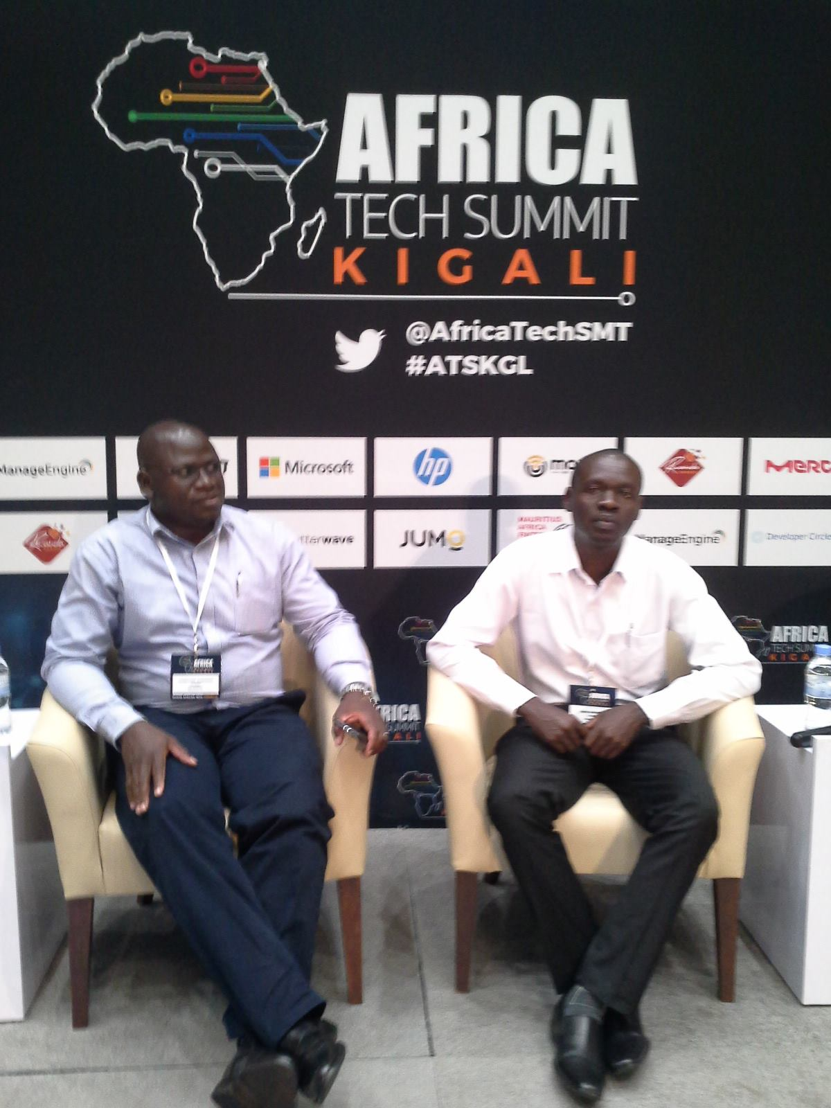

## **3.3 Africa Tech Week – Cape Town, Southern Africa**

ToroDev was also invited in the Africa Tech Week - March 2019, which was hosted in Cape Town, South Africa to discuss new ICT trends and innovations on the African continent and beyond. ToroDev was identified mainly to share experiences in its work and the recent MML eParticipation System Model to improve service delivery that it was piloting in Uganda and parts of central Kenya.

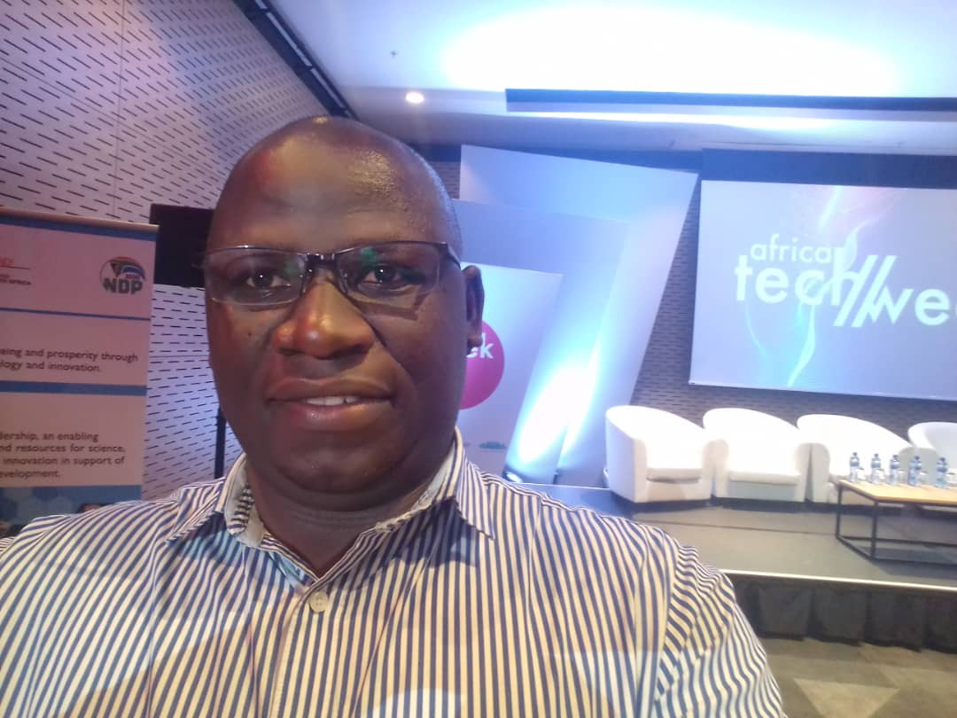

***ToroDev’s Johnstone Baguma during the Africa Tech Week in Cape Town, South Africa***

During this event, ToroDev also interacted with ICT industry leaders in Open Data that inspired more the establishment of the Open Data Analytics initiative in Uganda. More consultations and strategic partnerships building is underway to realize this conceptualization at ToroDev.

## **3.4 Stockholm Internet Forum – Stockholm, Sweden**

The SIF2019 was organized by SIDA – The Swedish International Development Cooperation Agency, one of the key funding partners of ToroDev. Among other issues at SIF, the members of the ICT4Democracy Network in Eastern Africa were able to interact at SIDA headquarters and also be acquainted with the new SIDA international development support focus, effective 2021.

During the visit to Stockholm, ToroDev and other partners were also able to visit SPIDER – The Swedish Program on ICT in Developing Regions at Stockholm University. SPIDER is a long time support (technical and financial of ToroDev) since 2012.

This forum attracted internet industry players, who included, Google Foundation, Mozilla, Microsoft and Facebook. Government ICT regulators like the Uganda Communications Commission, Communications Commission of Kenya, among others in East Africa also attended.

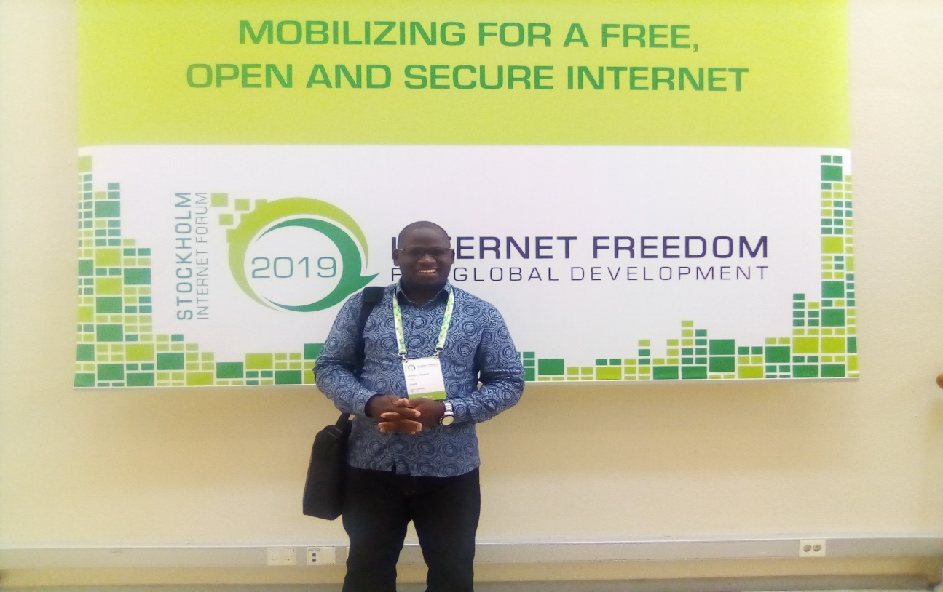

***ToroDev’s Johnstone Baguma at the SIF 2019, Stockholm, Sweden***

During the SIF 2019, ToroDev was able to interact with an Open Data Analytics and Visualization firm, THIBI, based in Singapore to build its capacity in this new ICT area.

## **3.5 UPR and FIFA 2019– Addis Ababa, Ethiopia**

The FIFAfrica 2019 was held in Addis Ababa between 23rd -26th September 2019. Before the official FIFAfrica 2019 opening ceremony on 25th September 2019, there were pre-session arrangements including training in Internet Freedom and Universal Periodic Review (UPRoar) where Toro Development Network was represented by the Strategic Partnerships and Communications Officer, David Kugonza.

The UPRoar training was organized by Collaboration on International ICT Policy for East and Southern Africa (CIPESA) and had participation of civil society representatives, journalists, lawyers, bloggers among others doing their work in promoting Human Rights from their respective countries. The Universal Periodic Review (UPR) is an Assessment of a Country’s Human Rights that happens every four and a half years for every state. Every United Nations (UN) member state has it’s human rights record assessed and all member states are involved in the review process. Human Rights Council (HRC) make submissions at the UN Assembly from Countries which result into Country’s recommendation for action.

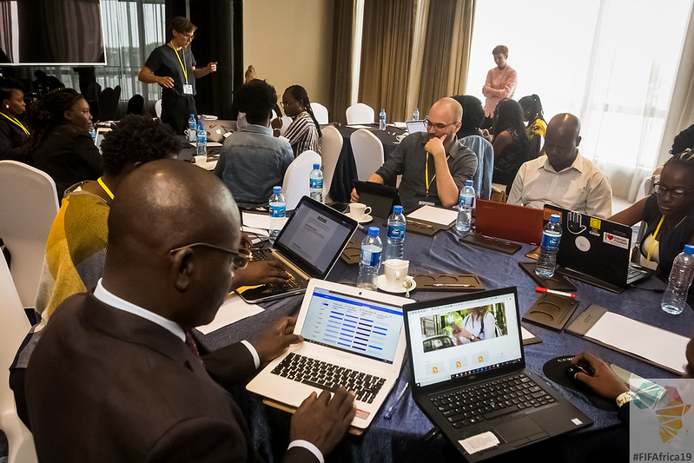

***ToroDev’s David Kugonza and other participants during the UPR training in Addis Ababa***

The UPRoar training aimed at building capacity, increasing participation and encouraging collaboration among actors in human rights network and also increasing participation by African civil society in the UPR process where the work of human rights actors would be increased especially that which promote internet freedom through the UPR.  It also aimed at increasing awareness among organizations on the cycle periods and opportunities to make submissions or statements, improve the capacity of actors to make submissions focusing on knowledge and skills at fronting interventions in research, training and support for African civil society to deliver stakeholders submissions on digital rights and offline rights.

# 4.0 Summary of ToroDev’s Key Technical & Funding Partners

* SIDA – The Swedish International Development Cooperation Agency, Sweden
* NED – The National Endowment for Democracy, USA
* AidData, College of William and Mary, Virginia, USA
* SPIDER – The Swedish Program for ICT in Developing Regions, Stockholm University
* CIPESA – The Collaboration on ICT Policy for Eastern and Southern Africa, Uganda
* WOUGNET – Women of Uganda Network, Uganda.
* AFRITECH – African Research of ICT for Development, Uganda.